CASE STUDY

AIM:
Uber Supply and Demand Gap Analysis

INTRODUCTION:
Analysing and visualizing the Supply and Demand. The Uber dataset is downloaded from kaggle. We will use POWER BI for data visualization & for data analysis.

PROBLEM STSTEMENT:
- Analysis preparation
- What is total requests by status
- What is total requests by pickup point
- What is the Demand by date
- Count of Requests and Drivers

METHODOLOGY:
Analysing and visualizing the Supply and Demand. The Uber dataset is downloaded from kaggle. We will use POWER BI for data visualization & for data analysis.
Data collecting method:
We imported the data into POWER BI.
Removed NULL values.

Datasets Columns:
- Request id
- Pickup point
- Driver id
- Status
- Request timestamp
- Drop timestamp

ANALYSIS:
What is total requests by status
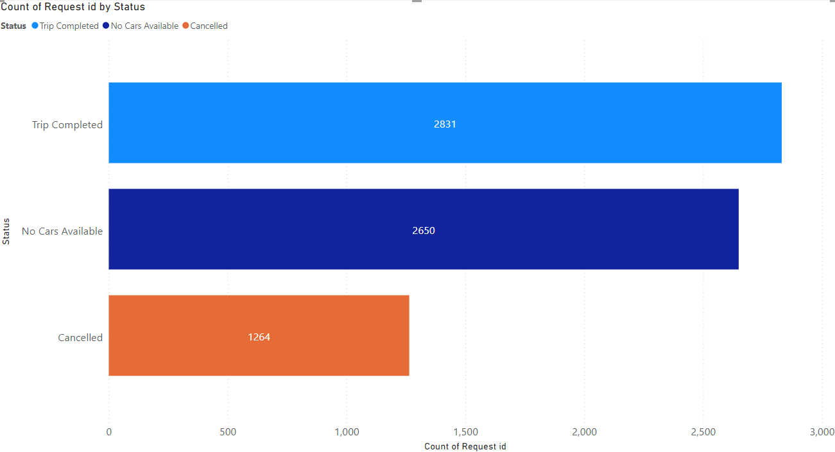
﻿Trip Completed had the highest Count of Request id at 2,831, followed by No Cars Available at 2,650 and Cancelled at 1,264.

What is total requests by pickup point
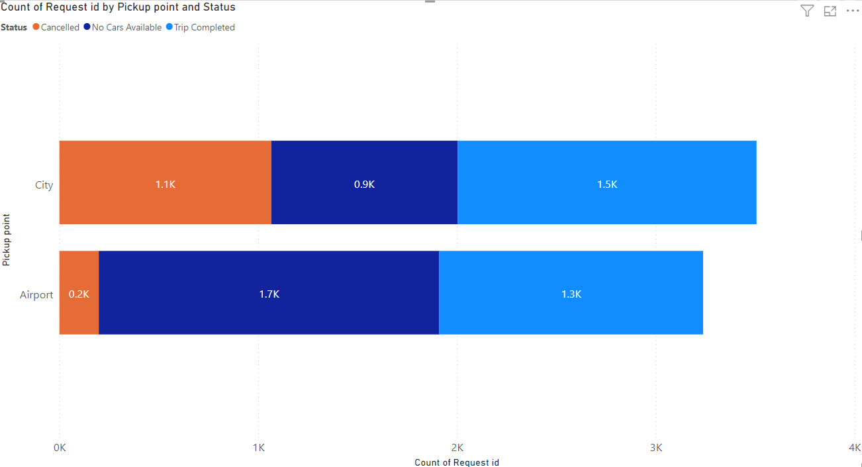
﻿Trip Completed had the highest average Count of Request id at 1,415.50, followed by No Cars Available at 1325 and Cancelled at 632.

What is the Demand by date

Drop time
Year | Month | Day | Status | Count of Request id
 |  |  | Cancelled | 1264
 |  |  | No Cars Available | 2650
2016 | July | 11 | Trip Completed | 582
2016 | July | 12 | Trip Completed | 568
2016 | July | 13 | Trip Completed | 569
2016 | July | 14 | Trip Completed | 536
2016 | July | 15 | Trip Completed | 546
2016 | July | 16 | Trip Completed | 30

Request time
Year | Month | Day | Status | Count of Request id
2016 | July | 11 | Cancelled | 262
2016 | July | 11 | No Cars Available | 504
2016 | July | 11 | Trip Completed | 601
2016 | July | 12 | Cancelled | 240
2016 | July | 12 | No Cars Available | 505
2016 | July | 12 | Trip Completed | 562
2016 | July | 13 | Cancelled | 270
2016 | July | 13 | No Cars Available | 490
2016 | July | 13 | Trip Completed | 577
2016 | July | 14 | Cancelled | 252
2016 | July | 14 | No Cars Available | 571
2016 | July | 14 | Trip Completed | 530
2016 | July | 15 | Cancelled | 240
2016 | July | 15 | No Cars Available | 580
2016 | July | 15 | Trip Completed | 561

Count of Requests and Drivers
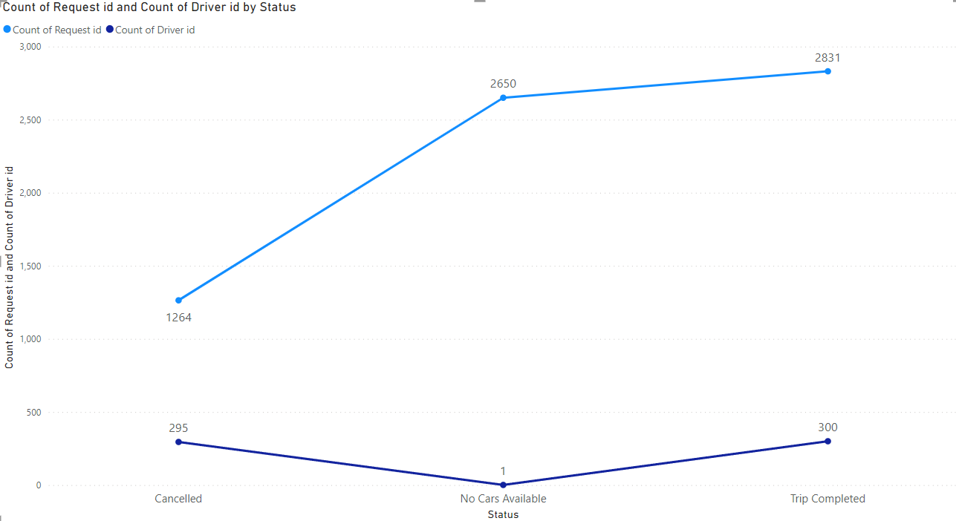
﻿No Cars Available had 2,650 Count of Request id and 1 Count of Driver id. Trip Completed had 2,831 Count of Request id and 300 Count of Driver id. Cancelled had 1,264 Count of Request id and 295 Count of Driver id.

INSIGHTS:
Request id, Pickup point, Driver id, Status, Request timestamp, Drop timestamp are mainly used for the analyse the dataset.

CONCLUSION:
Trip Completed had the highest Count of Request id at 2,831, followed by No Cars Available at 2,650 and Cancelled at 1,264.
Trip Completed had the highest average Count of Request id at 1,415.50, followed by No Cars Available at 1325 and Cancelled at 632.
No Cars Available had 2,650 Count of Request id and 1 Count of Driver id. Trip Completed had 2,831 Count of Request id and 300 Count of Driver id. Cancelled had 1,264 Count of Request id and 295 Count of Driver id.

